POD|LCA Materials Tool

Quick Start Guide

Installation
- The code base is available at https://github.com/POD-LCA/pod_lca. It is a private repository. With read access, you can download (or clone) the repository. (Cloning a repository with Git or a Git client would allow you to pull changes whenever the updated versions are available, as opposed to downloading all files every time a software update is made)
- POD|LCA Material Tool is built using Python programming language and using a few other dependent packages. You need to install the following list of packages along with Python.
- Python==3.11.9
- numpy==1.26.4
- pandas==2.2.2
- matplotlib==3.9.2
- mplcursors==0.5.3
(TBD): Create installer to do the above steps.
- Open the Windows command prompt and navigate to the folder \pod_lca. Once there, type python -m GUI.gui and press enter. The POD|LCA Material Tool window will pop up.

The Graphical User Interface (GUI)
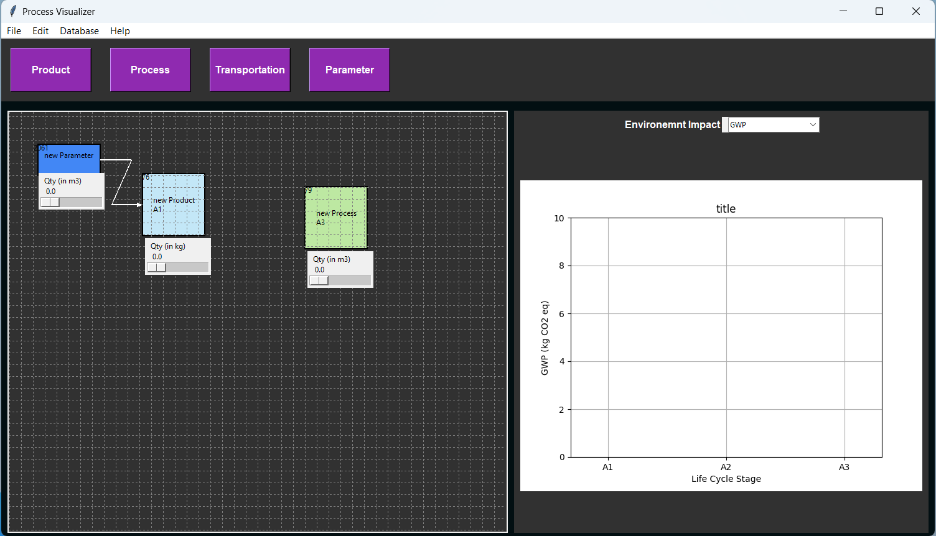
Figure 1 - POD|LCA Material Tool GUI.
Palette
Menu bar
Plotter
Canvas
The graphical user interface (GUI) of the POD|LCA Material Tool has 4 main components: Menu bar, Palette, Canvas, and Plotter (Figure 1).

Menu Bar
The Menu Bar provides access to key functionalities such as opening and saving files, editing settings, and other tool-specific commands. It is your control center for navigating through the tool's features.

Canvas
The Canvas is the workspace where the process flow is built. You add products and processes from the palette and place them on the Canvas. You can connect products and processes, move items around the canvas, and navigate the Canvas.

Palette
The components you can add to the Canvas are in the Palette. Clicking the corresponding item on the Palette will create it and place it on the Canvas.

Plotter
The Plotter area displays the environmental impacts in bar charts updated in real-time. It is tightly integrated with the Canvas, allowing you to update plots dynamically as inputs change on the Canvas.

Create New Project
(TBD): Issue #18: New project wizard.
File > New will clear the current canvas and all background data (except for the impacts database).
File > Open will let you open saved projects (along with the impact databases attached to the project).

Importing Impact Data
Database > Import prompts you to import the database from a file.
(TBD): Issue #4: Custom impact addition and more flexibility with importing data base from files.
(WARNING): The imported file needs to be *.CSV with columns in the following order: flow, units, GWP (in kg CO2 eq), Acidification potential (kg SO2 eq), Eutrophication potential (kg N eq), Ozone depletion potential (kg CFC-11 eq), Smog potential (kg O3 eq).

Navigating the Canvas
Hold Right Mouse Button and Drag: Pan
Mouse Scroll Wheel: Zoom out/in
Ctrl+ / Ctrl-: Zoom out/in
Edit > Canvas Settings allows you to change canvas settings including background color, and grid properties.

Building the Process Flow

Add item
Select items from the palette to add them to the Canvas. A prompt will appear to provide details on the item added (e.g., Figure 2). These details are initial settings and can be changed later. Once pressed OK, the item will appear on the canvas (Figure 3).
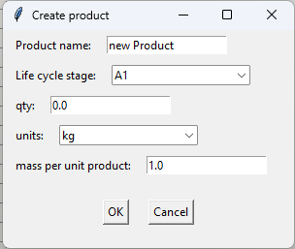
Figure 2 - Create product pop-up
Once added to the canvas, the quantity parameter can be changed on the slider. In contrast, the other (harder) parameters (i.e., item name, units, and the life cycle stage) can be changed on the item's context menu (appears with a click of the Right Mouse Button on the item- see Figure 4).
The item context menu can also be used to change the quantity slider properties: the minimum, the maximum, and the resolution of the quantity slider.
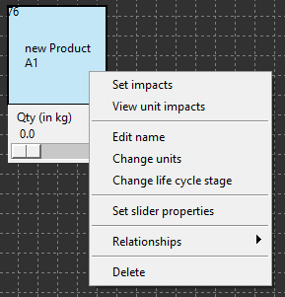
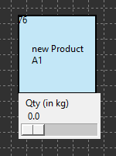
Figure 3 - Item on canvas.
Qty slider
Item display id
Item label
(name and LC stage)
Figure 4 - The item context menu can be viewed by right-clicking.
Items can be dragged on the canvas by clicking and holding the left mouse button while dragging the item.
Edit > Canvas Settings allows you to change the color of different types of items (i.e., products, processes).

Connect items
Items can be connected. Click the Left mouse button on the start item while holding down the ctrl, and drag the cursor (while holding down the ctrl key and left mouse button) to the end item. This will connect the start and end items (Figure 5). Do the same with the shift key held down to delete a connection.
The two items will not connect if:
- If a product is connected to another product. Combining two products has to be done through a process
- If what is connected to a transportation process is not a product. Only products can be transported.
Edit > Canvas Settings allows you to change the connector type.
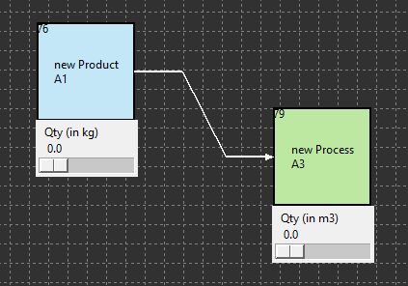
Figure 5 - Connecting two items. The connector arrow is from the start item to the end item.

Delete
Selecting Delete on the context menu of the item (Figure 4) will delete it from the canvas. This will also delete any connections to or from the item as well.

Set impacts
You can select from the item context menu (Figure 4) the database item corresponding to the product or the process.
(TBD): Management of setting impacts for units consistency.
(WARNING): The units of the item and the impact should match.
Once set you can view the unit impacts of the product or the process in the item context menu.

Set relationships
Relationships can be set between the quantities of the items. This will make the quantity of an item on the canvas dependent on other items (masters). Setting a relationship will disable the quantity slider of the dependent item and will automatically update when the sliders of master(s) are changed.
Relationships can be set on the current item through its context menu: the relationship can be set as a mathematical expression. The items are identified by their display IDs (see the top left corner of the item on the canvas) written inside curly brackets (‘}’ and ‘{‘). The following mathematical expressions are recognized: add ‘+’; deduct ‘-’; multiply ‘*’; divide ‘/’; raise to the power ‘**’. Only the numerical value of the master item(s) quantity is taken and no unit conversions or checks are done.
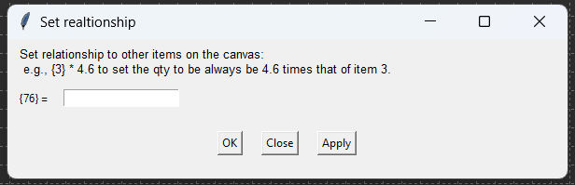
Figure 6 - Set relationship dialog box where relationships between items can be set as a mathematical expression.
Pressing the Right Mouse Button on an item while holding down the Shift Key will highlight items dependent on the current item quantity value, as set through relationships.

Number Parameter
The number parameter is a slider without an underlying product or process. This item is created to facilitate parametric changes, along with Set relationships. Connecting a parameter to a product or a process item will automatically set a one-to-one relationship with the parameter (i.e., the quantity value of the dependent item will be the same as the parameter value).
The context menu allows similar changes to the item (i.e., change name and units) and the slider properties.
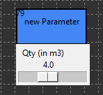
Figure 7 - Parameter item.

Unit conversions
Unit conversions are automated. The conversions database will do the following conversions.
- 1000m = 1km = 0.621371 mi
- 1000g = 1kg = 0.001t = 2.20462lb
- 1l = 0.01m3 = 0.264172gal
- 1000J = 1kJ = 0.001 MJ = 2.77778e-4kWH = 2.77778e-7MWh
- 1kgkm = 0.01tkm = 1.369887lbmi
(TBD): Issue #20: A comprehensive conversion database handling compound units and metric prefixes.

Visualizing Results
Visualizer will automatically update results as the process flow is built. A drop down list allows to pick impacts to be plotted.
(TBD): Issue #10: Expand the types of data visualization

Reports
(TBD): Generating Excel or PDF reports

Save and close
File > Save As will allow you to save your project. It will prompt you to select a folder to save the project data to.
File > Save will let you save your progress on a project. If the project has not yet been saved, it will prompt you to Save As.
File > Save As will allow you to save your project. It will prompt you to select a folder to save the project data to.
Saved pickled files are made safe with a binary key saved in ‘\GUI\Examples\key.txt’. This key and the keygen.py are not shared on the GitHub repository and will be privately shared on a secured communication line.
File > Close will terminate the application.

Developer Guide

Program structure

Class diagram

GitHub repository

Creating issues

Working on Branches
// how to create a branch

